ISTE-230 Introduction to Database & Data Modeling

## Practice Exercise # 14 – Queries and Functions

**Name: _____________________________________________**

**PART 1**

Download the PE14.sql script execute it to create the database shown in the ER diagram below. For each of tasks, make no assumptions about the data that is in the database. That is, do not structure your queries based on any data values you see in the database. Appendix A should be used as a reference. It contains the results of a DESCRIBE, as well as a SELECT, from each table.

**Put your answers in a script called '*your_lastname*_PE14p1.sql'**. Include a comment before each statement to denote the task number.



Task 1

Write a query to display model, manufacturer, serial number, processor speed, and memory for the computer with item id = 3:

+-----------+--------------+--------------+----------------+--------+

| model | manufacturer | serialNumber | processorspeed | memory |

+-----------+--------------+--------------+----------------+--------+

| OfficePro | Bell | abc234 | 800 | 256meg |

+-----------+--------------+--------------+----------------+--------+

1 row in set (0.00 sec)

Task 2

Write a query to display the lease number, salesperson, item id, and quantity for any trucks leased:

+-------------+-------------+--------+----------+

| leasenumber | salesperson | Itemid | quantity |

+-------------+-------------+--------+----------+

| 1 | John Smith | 5 | 4 |

| 1 | John Smith | 6 | 2 |

| 1 | John Smith | 7 | 1 |

| 1 | John Smith | 8 | 1 |

+-------------+-------------+--------+----------+

4 rows in set (0.02 sec)

Task 3

Write a query to display all attributes (supertype and subtypes) for item id = 7.

**\* Attribute names have been abbreviated only to save space and get output in a readable format. Your headings do NOT need to match what is shown below.**

+------+-----+----------+--------+---------+------+------+---------+------+------+--------------+

|ItemID|Type |Manufactur|Model |LeaseRate|ItemID|SerNum|ProcSpeed|Memory|Dimens|HardDriveSpace|

+------+-----+----------+--------+---------+------+------+---------+------+------+--------------+

| 7 |Truck|Industrial|Flat Bed| 800 | NULL | NULL | NULL | NULL | NULL | NULL |

+------+-----+----------+--------+---------+------+------+---------+------+------+--------------+

----------+------+------+-----+-----------+---------+------+----------+------+-----+------+-------+

CDRomSpeed|ItemID|VinNum|Color|MilesPerGal|TransType|TowCap|NumOfAxles|ItemID|Dimen|Weight|Color |

----------+------+------+-----+-----------+---------+------+----------+------+-----+------+-------+

NULL | 7 | 12347|Black| 10 | Manual |14000 | 3 | NULL |NULL | NULL | NULL |

----------+------+------+-----+-----------+---------+------+----------+------+-----+------+-------+

**PART 2**

Download the createBOOK.sql script execute it to create the database shown in the ER diagram below. Add your statements for this part to the '*your_lastname*_PE14.sql' script that you created for Part 1. Add a comment before each statement with the task number.

Use the BOOK database to answer the following queries.

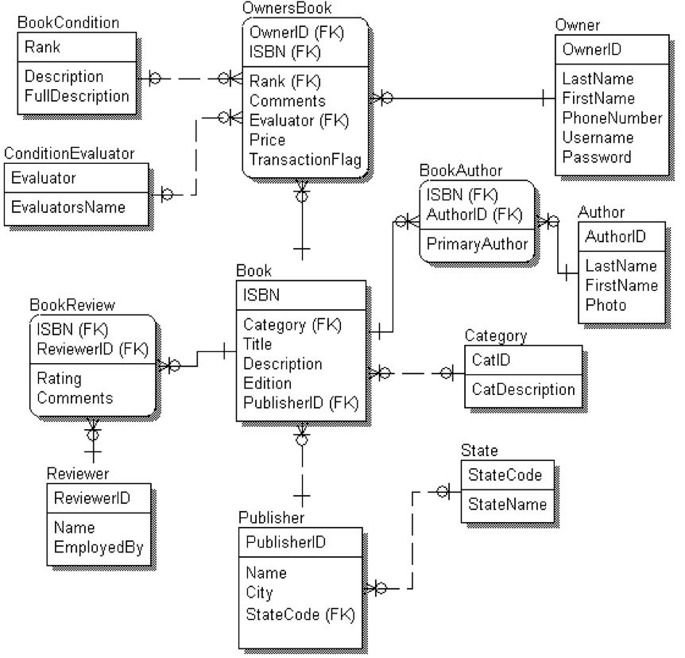

Captured in English, the entities of this Universe of Discourse, and the relationships among them, can be described like this:

|  |  |
| --- | --- |
| **Book** | .. (1) identified by an **ISBN**, (2) written by one primary **BookAuthor** and zero or more secondary **BookAuthors**, (3) categorized by subject matter **Category**, (4) published by **Publisher**, and (5) reviewed in a given **BookReview** |
| **BookAuthor** | .. individuals that are either the primary or secondary author(s) of a specific **Book** occurrence |
| **Author** | .. individuals that are primary or secondary authors |
| **BookReview** | .. the rating assigned to a specific **Book** occurrence by a given **Reviewer** |
| **Reviewer** | .. individuals that review **Book**s and assign a rating to it |
| **OwnersBook** | .. **Book**s *owned* by **Owners** that are deemed to be in a certain **Condition** as rated by a **ConditionEvaluator** |
| **Owners** | .. individuals that *own* **OwnersBook**s |
| **Condition** | .. the set of **Condition “**rankings” (1..5, corresponding to “bad”, “poor”, “average”, “good” and “excellent”) that can be assigned to an **OwnersBook** |
| **ConditionEvaluator** | .. individuals that evaluate the condition of a book and assign a **Condition** to it |
| **Category** | … the set of **BOOK** subject matter classifications |
| **Publisher** | .. publishes **BOOK**s in a given U.S. **State** |
| **State** | .. state codes and full state names |

Task 4

Display the reviewer’s name, book title, and rating for books that have a rating between 5 and 7. Sort the results by rating in descending order and then by title in ascending order.

+-------------+-------------------------------------------+--------+

| Review Name | Book Title | Rating |

+-------------+-------------------------------------------+--------+

| Youngfellow | From Brockport to IT | 7 |

| Lester | How to Keep your Cable Bill Down | 7 |

| Lester | How to Keep your Cellular Bill Down | 7 |

| Wheaton | I Lasted my Love's Last Lingering Longing | 7 |

| Wheaton | My Love's at Long Last Lost his Lingering | 7 |

| Lester | From Deep in the Heart of Texas to IT | 6 |

| Stratson | Yes! Networking is for Bills Fans | 6 |

| Kurtzweill | Yes! Networking is for Bills Fans | 5 |

+-------------+-------------------------------------------+--------+

8 rows in set (0.00 sec)

Task 5

List the owners and the books they own. List owners even if they do not own a book. List the owners first and last name and the book’s title.

+-----------+---------------+-------------------------------------------------+

| FirstName | LastName | Title |

+-----------+---------------+-------------------------------------------------+

| Martha | Tripplewander | How to Keep your Cable Bill Down |

| Martha | Tripplewander | I Lasted my Love's Last Lingering Longing |

| Martha | Tripplewander | My Lost Love's Long Last Lingering |

| Martha | Tripplewander | The Shortest Book in the World |

| Francis | Scott | Yes! Networking is for Bills Fans |

| Roda | Ribblemaze | NULL |

| George | Rabblewok | How to Keep your Cellular Bill Down |

| George | Lumberworker | From the Shores of Lake Erie to IT |

| Wei | Ling | From Deep in the Heart of Texas to IT |

| Wei | Ling | My Love's at Long Last Lost his Lingering |

| Wei | Ling | The Science of Literature Searching |

| Gus | Fribblestone | NULL |

| Scott | Francis | ER, SOM, NF, DK/NF, SQL, JDBC, ODBC, and RELVAR |

| Scott | Francis | How to Keep your Cellular Bill Down |

| Frederick | Ferblemander | NULL |

| Ira | Corplestein | ER, SOM, NF, DK/NF, SQL, JDBC, ODBC, and RELVAR |

| Leslie | Corplestein | From Deep in the Heart of Texas to IT |

| Leslie | Corplestein | From the Shores of Lake Erie to IT |

| Ira | Corplestein | How to Keep your Cellular Bill Down |

| Leslie | Corplestein | My Love's Last Longing |

| Ira | Corplestein | Yes! Networking is for Bills Fans |

| Mary | Burblemonger | My Love's Last Lingering Lost |

+-----------+---------------+-------------------------------------------------+

22 rows in set (0.00 sec)

Task 6

Show the publisher name and location (as shown below), count of their ISBN numbers, length of the longest title, and length of the shortest titles for books published by publishers that have ‘read’ in the publisher’s name (you MUST use INSTR()) and that have published MORE than one book.

+-----------------------------------------------+-------+-------------+--------------+

|Publisher Name and Location |# Books|Longest Title|Shortest Title|

+-----------------------------------------------+-------+-------------+--------------+

|EZRead Masterpiece Comics in New York, NY | 3 | 42 | 37 |

|ReadEmandWeep Romance Publishing in Chicago, IL| 5 | 41 | 22 |

|ReadMeFirst House of Publishing in New York, NY| 2 | 35 | 33 |

|ReadMeNext House of Publishing in New York, NY | 2 | 36 | 32 |

+-----------------------------------------------+-------+-------------+--------------+

4 rows in set (0.00 sec)

Task 7

Show the title and its average rating, rounded to the nearest whole number, and the first 20 characters of the book's description, for all books that have ‘THE’ in the title in descending order by average rank and title. Make sure that case does not impact your results. Your output should match the display given below:

+-------------------------------------------+------------+------------------------+

| Title | Avg Rating | Description Excerpt |

+-------------------------------------------+------------+------------------------+

| The Shortest Book in the World | 10 | A Guide to how Detro...|

| From Deep in the Heart of Texas to IT | 6 | One man's Journey to...|

| From the Shores of Lake Erie to IT | 4 | One man's Journey to...|

| The Science of Literature Searching | NULL | A Book Worth a Look ...|

| Master Wireless Through The Classic Comics| NULL | Infrared man triumph...|

| Master HTML Through The Classic Comics | NULL | Using his Super Web ...|

| Master C++ Through The Classic Comics | NULL | GeekMan triumphs ove...|

+-------------------------------------------+------------+------------------------+

7 rows in set (0.00 sec)